Auto-QCA: Technical Documentation
- Overview
Auto-QCA is an automated Qualitative Comparative Analysis (QCA) tool designed for social science researchers. Built on the Python programming language and the Streamlit framework, it operates as an interactive web-based interface within a browser environment.
The core innovation of the tool lies in integrating Large Language Models (LLMs) into the text (Chinese mainly) coding stage of QCA, enabling an end-to-end automated workflow from raw textual data to complete QCA results. The entire process is conducted without requiring users to manually write or modify code.
The tool’s source code is hosted on GitHub, and researchers can launch it locally by following the steps below:
git clone https://github.com/[用户名]/auto-qca.git
cd auto-qca
pip install -r requirements.txt
streamlit run app.py

- Functional Modules and Required Data
The tool operates through seven sequential stages, covering the full analytical pipeline of QCA:

Stage 1: Data Input

The tool accepts text datasets in CSV format, where each row represents a case and includes two columns:
- Case text
(2) Outcome variable (coded as 0/1)
Users may upload CSV files directly or manually paste data into the interface.

Stage 2: Model Configuration


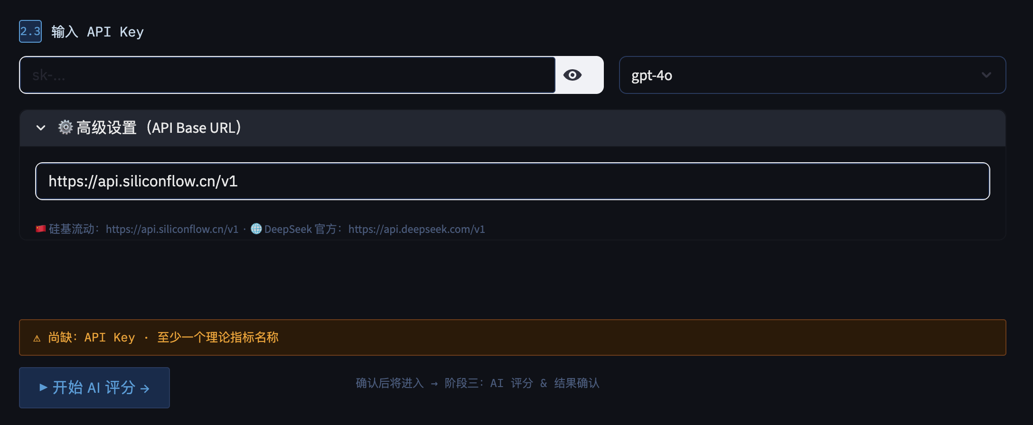

Researchers define theoretical indicators, each comprising three components:
- Indicator name
(2) Theoretical description (including literature references and conceptual definitions)
(3) Operationalization criteria (explicit coding rules for high/medium/low levels)
Researchers need to choose:
- fsQCA (fuzzy-set QCA)
- csQCA (crisp-set QCA)
At this stage, researchers also need to configure API keys and select the desired language model.

Stage 3: AI-Based Scoring and Validation


Using an OpenAI-compatible API, the tool evaluates each case text according to the theoretical indicators and operational criteria.
- In fsQCA mode, scores range from 0.00 to 1.00
- In csQCA mode, scores are binary (0 or 1)
A score distribution visualization is generated. Researchers can review AI-generated coding rationales for each case and manually adjust scores if necessary.
Prompts for this stage is as follow：
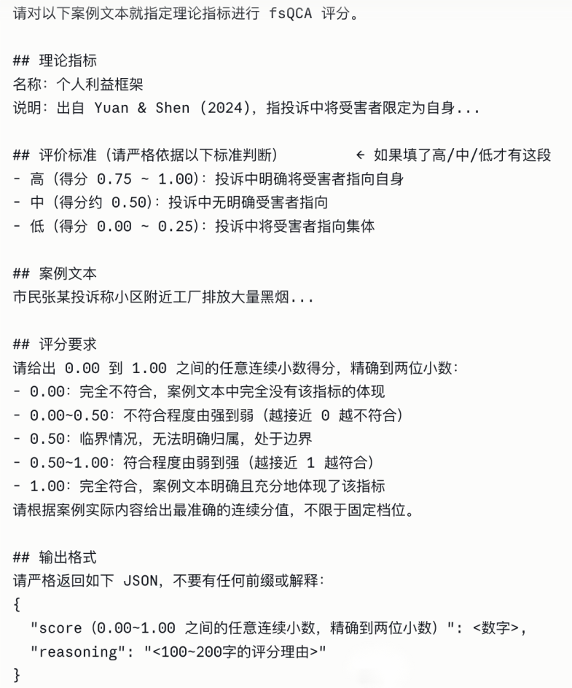

Stage 4: Fuzzy-Set Calibration

(Executed only in fsQCA mode)
Following the direct calibration method proposed by Ragin and Fiss (2008), users set three thresholds:
- Full membership (default: 0.95)
- Crossover point (default: 0.50)
- Full non-membership (default: 0.05)
These thresholds convert raw scores into theoretically meaningful membership values. A heatmap of membership scores is also generated.

Stage 5: Necessity Analysis

The tool calculates the consistency and coverage of each condition (and its negation) with respect to the outcome variable.
Conditions meeting the default necessity threshold (consistency ≥ 0.90) are flagged as necessary.

Stage 6: Sufficiency Analysis (Configurational Analysis)

This stage consists of three steps:
- Truth Table Construction
Based on user-specified thresholds for: Frequency;Consistency (default: 0.80);PRI (Proportional Reduction in Inconsistency, default: 0.75)
- Boolean Minimization
The tool derives: Complex solutions; Parsimonious solutions
It adopts the standard notation system of Ragin and Fiss (2008), using symbols such as ● (presence) and ⊗ (absence) to distinguish core and peripheral conditions.
- Interpretation Support
The tool employs LLMs to generate academic-style labels for each configuration path and produces a consistency–coverage scatter plot.

Stage 7: Results Export
All intermediate results and outputs are compiled and made downloadable, including:
- CSV files
- Visual figures

- Outputs
The tool generates the following standardized outputs:
- Raw text-scoring table
- Calibrated membership scores table
- Necessity analysis results
- Truth table
- Configurational solution table (including consistency, raw coverage, unique coverage, and overall solution metrics)
- Visualizations:
Score distribution plot; Membership heatmap; Consistency–coverage scatter plot

- Core Dependencies
Package | Function
streamlit | Web-based interactive interface
pandas | Data processing and tabular operations
numpy | Numerical computation (consistency/coverage calculations)
matplotlib / seaborn | Visualization
requests | API calls to LLM services

- References and Algorithmic Foundations
Calibration Method
- Ragin, C. C., & Fiss, P. C. (2008). Net Effects Analysis versus Configurational Analysis. In Redesigning Social Inquiry: Fuzzy Sets and Beyond (pp. 190–212).
Truth Table and Boolean Minimization
- Dușa, A. (2019). QCA with R: A Comprehensive Resource. Springer.
- Thiem, A., & Dușa, A. (2013). Qualitative Comparative Analysis with R: A User's Guide. Springer.
Threshold Selection Guidelines
- Schneider, C. Q., & Wagemann, C. (2012). Set-Theoretic Methods for the Social Sciences. Cambridge University Press.
- 陶克涛, 张术丹, & 赵云辉. (2021). 什么决定了政府公共卫生治理绩效？——基于QCA方法的联动效应研究. 管理世界, 37(5), 128–136.
- 杜运周, & 贾良定. (2017). 组态视角与定性比较分析（QCA）：管理学研究的一条新道路. 管理世界, 33(6), 155–167.

